**Troubleshooting Beats**

* all the elastic componets logs can be viewed using journalctl journalctl -u heartbeat-elastic.service
* look into yaml for syntax issues and cloud id and auth for configuration
* ensure metrics are enabled  
  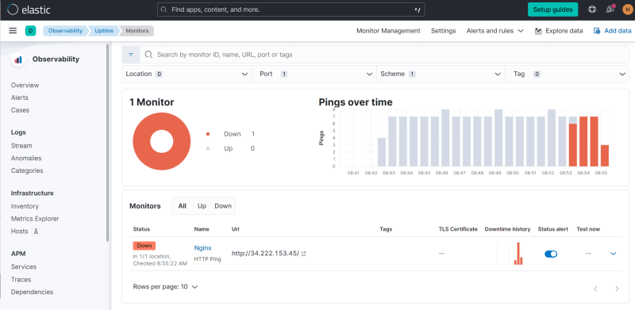  
  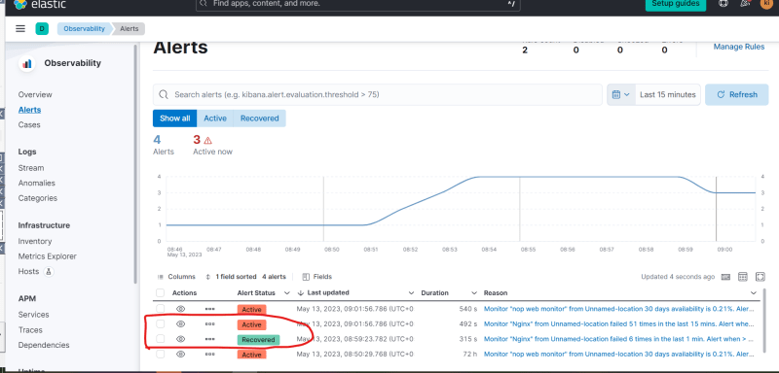

**Metric Beat**

* This beat collects metrics about system and some predefined applications
* Install metric beat <https://www.elastic.co/guide/en/beats/metricbeat/8.7/setup-repositories.html#_apt>
* We will get system and nginx metrics to elastic cloud in next session